Feedback/Edits for dashboard themes page

Red text is indication of text updated (prob best to cut-n-paste to make sure all edits captured)

# transport

## Dublin Bikes

The pop-up data box does not appear at all when I hover over graph in Firefox. In Chrome it appears in top left, but moves about the screen. There is no button to move between views in either browser. There also needs to be a date on the graph – this is for yesterday, not today? It says Wed 20 at end of time axis, but not sure what that refers to.

What happened to the map of Dublin Bikes – in a different section (tasks?). If so, we need a link here to that.

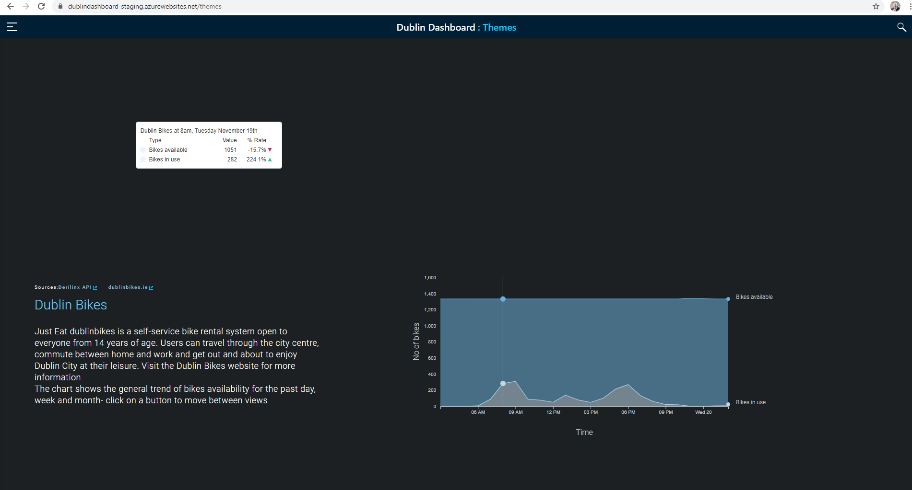

Update text:

Just Eat dublinbikes is a self-service bike rental system open to everyone over the age of 14. Users can travel throughout the city centre, commute between home and work and get out and about to enjoy Dublin City at their leisure. Visit the Dublin Bikes website [http://www.dublinbikes.ie/] for more information.

The chart shows bike usage and availability for the past day, week and month - click on the tabs to move between views. In the past day, the maximum number of bikes in use was **355** at **18:00**, meaning there were still **1012** bikes available city-wide.

The current **202** bikes available is **10% more than** at this time yesterday.

To view the availability of bikes at each stand see our interactive map [need weblink].

## Traffic counters

Need the number on the left hand side of graph line as well (in this case at 1-12-19) so can really see what the fall was rather than an abstract sense of it.

Also, what is the number? Average vehicles per hour, at a particular time? I don’t know how to interpret this at minute.

Is 1-12-19 arbitrary? At minute showing a 5.5 month range. Should the graph be for previous 6 months? Do we want to give people the option of looking at longer/shorter timeframes?

Do we have counters for inside the M50 at all?

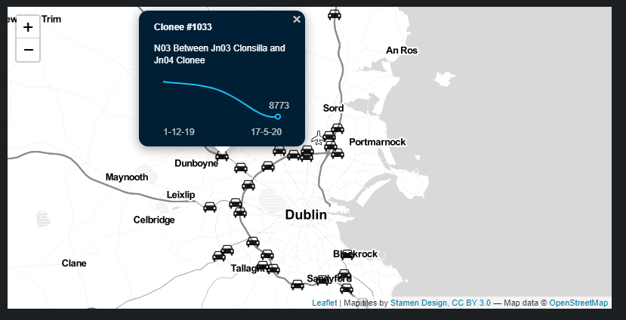

I think it might be useful to include the data NRA does. AADT (Annual average daily traffic) and % HGV for day, month, year.

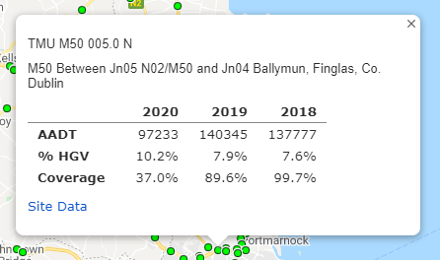

Text: Traffic Infrastructure Ireland maintains several traffic sensors along the motorways to count the number of vehicles. Vehicle sensors help track changes in road usage over time and estimate traffic volumes. This data is released as a yearly average daily number of vehicles.

Use the map to compare volume at sensors on the M50 over the last few months.

# Environment

## Noise Level Monitoring Sites

I’m not sure if this is elsewhere, but I think we should also have graphs showing sound level change over day, and perhaps in comparison to previous day? The pop-up graphs on the page in Firefox and Chrome are empty. Also on <http://dublin-noise.sonitussystems.com/charts.php> they have 19 sites not just 12 in DCC. Includes a couple of S. Dublin and Fingal. We should include if we can.

Text

Dublin City Council monitors ambient sound levels at 15 locations throughout the city. Click on a [icon] icon to see the name of the site and latest reading measured there.

Sound is represented in decibels (dB) which measure the amount of sound perceived by humans. Normal conversation is measured at around 60 dB, vacuum cleaners make about 70 decibels of sound, and a food blender is measured around 80 decibels.

Currently, **0.57%** of sound monitors are measuring sound levels higher than the EPA/WHO-designated desirable level of 55db in the **daytime**.

Over the past 24 hours, **9** of the city's 14 monitors have recorded sound levels higher that the EPA/WHO-designated undesirably high levels of 70 db during the daytime and 55 db at night.

## Water Monitoring Sites

Until you zoom in there is only one water station (in the sea) visible. It is not clear that there is any data there. Even when start to zoom in numbers are in white and difficult to see. Only when zoomed in twice see most of the water stations, and have to click on numbers to get more (but they are very difficult to see).

When click on a droplet the writing is brown on black and difficult to see. Most are inactive. For the active ones no data shows.

I would also make the water droplets blue – they are too near the black dots representing towns.

There is no button to switch between OPW and EPA sites.

Text

Two agencies, the Office of Public Works (OPW) and the Environmental Protection Agency (EPA), monitor water levels and flows along Dublin’s waterways. Use the buttons to switch between the OPW water level monitoring sites and the EPA Hydronet system sites. Click on the droplet icon on the map to get information for that location.

# Housing section

Descriptor: Housing trends for Dublin, highlighting affordability and housing supply.

## Average House Prices

It’s not really clear to me what the source of the data are once I get to the housing.gov website. ~~I think the CSO housing price index should be here as well as a separate tab, or one graph over the other as with monthly rental prices. Having them as two entries suggests they are showing different things, whereas they are showing the same thing in slightly different ways.~~

The CSO webpage also suggests has data for 4 Dublin LAs, if scroll down to graph at bottom. https://www.cso.ie/en/releasesandpublications/ep/p-rppi/residentialpropertypriceindexjanuary2020/

Text

~~Over the past decade house prices have fallen after the financial crash of 2008 followed by a period of recovery. This chart shows average house prices nationally and across the four Dublin local authorities for each quarter since the beginning of 2008. The data are derived from mortgage lending agencies on all loans approved (so excludes cash sales). Also, when comparing house prices figures from one period to another it should be noted that changes in the mix of dwellings for sale (houses vs apartments, number of bedrooms). The CSO monthly residential property price index (RPPI) shows average property prices from a baseline of 100 established in 2005.~~

## Monthly Residential Property Price Index

~~This graph should be a tab on the average house price. The text for it is already above.~~ I would also have Dublin houses and Dublin apartments on the graph, or on a separate tab again.

## Monthly Rent Prices for Private Dwellings

***Text***

~~The top graph shows the average rent being paid in Dublin since 2008. It fell in the wake of the financial crash before steadily starting to rise is now back above the peak a decade ago. The bottom graph shows standardised rent for one, two, three and four bedroom properties since 2016 on a quarterly basis. In all categories rents have been steadily rising.~~

## Quarterly New Dwelling Completions in Dublin County by Type

Why does this graph show Dublin as a whole rather than each of the four local authorities? The data is available at LA level so we should use. It probably needs a few tabs. Dublin as a whole, DCC, Fingal, SD, DLRD. One where can compare completions across all four.

I’ll then write text.

## Supply of land

~~If we can’t do this past 2014 then we should drop from the dashboard.~~

## Planning

Why has planning been dropped from the dashboard?

Add number of planning permissions received and given … <https://www.housing.gov.ie/planning/statistics/planning-statistics-1>

# Economy

~~Descriptor: Economic trends for Dublin, highlighting employment patterns.~~

Add the following, which is in the existing Dublin Dashboard …

<http://www.dublindashboard.ie/DublinEconomicMon/stats>

<http://www.dublindashboard.ie/Economy/stats/container>

## Gross Value Added per Capital at Basic Prices

## Employment in services

## Employment in broad sector

## Dublin airport numbers

## Dublin port tonnage

## Employment 🡪 change title to: Persons aged 15 and over in the labour force

~~I’m unsure of the use of k in the left hand axis. ‘2.2k thousand’ just seems a weird way of say 2.2m. I think it should go: 200k, 400k, 600k, 800k, 1m, 1.2m, 1.4m, 1.6m. The remove ‘Thousands’ and replace with k=thousands, m=millions.~~

***Changed data plotted to reflect title***

Text

~~Employment grew steadily throughout the Celtic Tiger period up until 2007, then fell in the wake of the financial crash, recovering after 2012 as the economy started to grow again. The pattern in Dublin mirrored that of the rest of the country.~~

**~~Unemployment~~** ~~🡪 change title to:~~ **~~Unemployed persons aged 15 or over~~**

~~I think there needs to be another tab here – unemployment rate as well as total numbers. The rate standardises it making it easier to make sense of. ILO rate is in the CSO link.~~

The left hand axis and the data don’t tie together. When I hover over the peak for ROI it says 328.1k whereas the x-axis indicates above 400k.

***stacked area- will add total to popup?***

Text

~~From 2000 to 2008 the unemployment rate in Ireland and Dublin was between 4 and 5 percent. As the financial crisis hit, the unemployment rate rose steadily to reach 15 percent nationally and 13 percent in Dublin. From the end of 2012 as the economy recovered it fell steadily.~~

# Education

Descriptor: Education trends for Dublin, highlighting pupil numbers.

## Pupil numbers

I’m not sure if the top graph is primary or secondary numbers – they need labelling.

I think they would be more effective as line not bar charts.

Text

# Health

**Remove health if we have nothing to put in it.**

**\*\* Ollys’ worikng on it\*\*\***

# Demographics

Descriptor: Population trends for Dublin

I wonder if this section shouldn’t have something on age profile, or at least numbers/% under 15 over 65, comparing Dublin with national rates, say from 1986 to present.

It would also be good to have something on social deprivation, though not sure of source for that.

## Population of Dublin

I’m presuming this is Dublin county and not Greater Dublin region

Text

The population of Dublin county has grown steadily in the past 100 years, as recorded in the censuses carried out every five years. This growth is a result of natural increase, but is driven in particular by internal national migration and international migration. The city has long had slightly more females than males, largely a function of a difference in average age of death.

## Number of households in Dublin

I suggest reordering so this is second presented.

I also suggest having a second tab which is the average household size.

Text

The number of households in Dublin has grown with the rise of population, but at an increased pace given a shrinkage in the average size of household. While the Dublin City Council area has had a sizeable growth in households since 1986, the growth in Fingal is more dramatic, over doubling its number of households.

## Population Born Outside the State

I think this needs another tab, which is proportion of overall population. This is actually more interesting as it shows the rate. I think that perhaps it should be a line graph and not histogram?

## Households by Number of Persons (2016)

~~I think this is fine as is.~~